**Pymacueticals potential treatments to SCC study**

In this animal study, 250 mice were treated through a variety of drug regimes over the course of 45 days. Their physiological responses were then monitored over the course of that time.

**observable trends based on the data for 4 drugs (capomulin, infubinol, ketarpril and placebo):**

1. tumor volume decreased for mice treated with capomulin and increased by using the other drugs (ketarpril has the most increased tumor volume).

Error bar for these data is very small that indicate that it’s somehow precise.

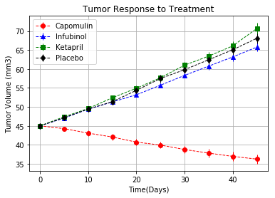

1. Cancer spread for all mice especially for the one treated with placebo

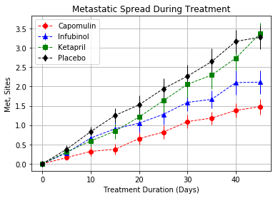

1. Capomulin give the mice a better chance to survive for longer time than other mice treated with other drugs (start with 25 mice and 21 survived) and infubinol has the least survival number (start with 25 mice and only 9 survived)

